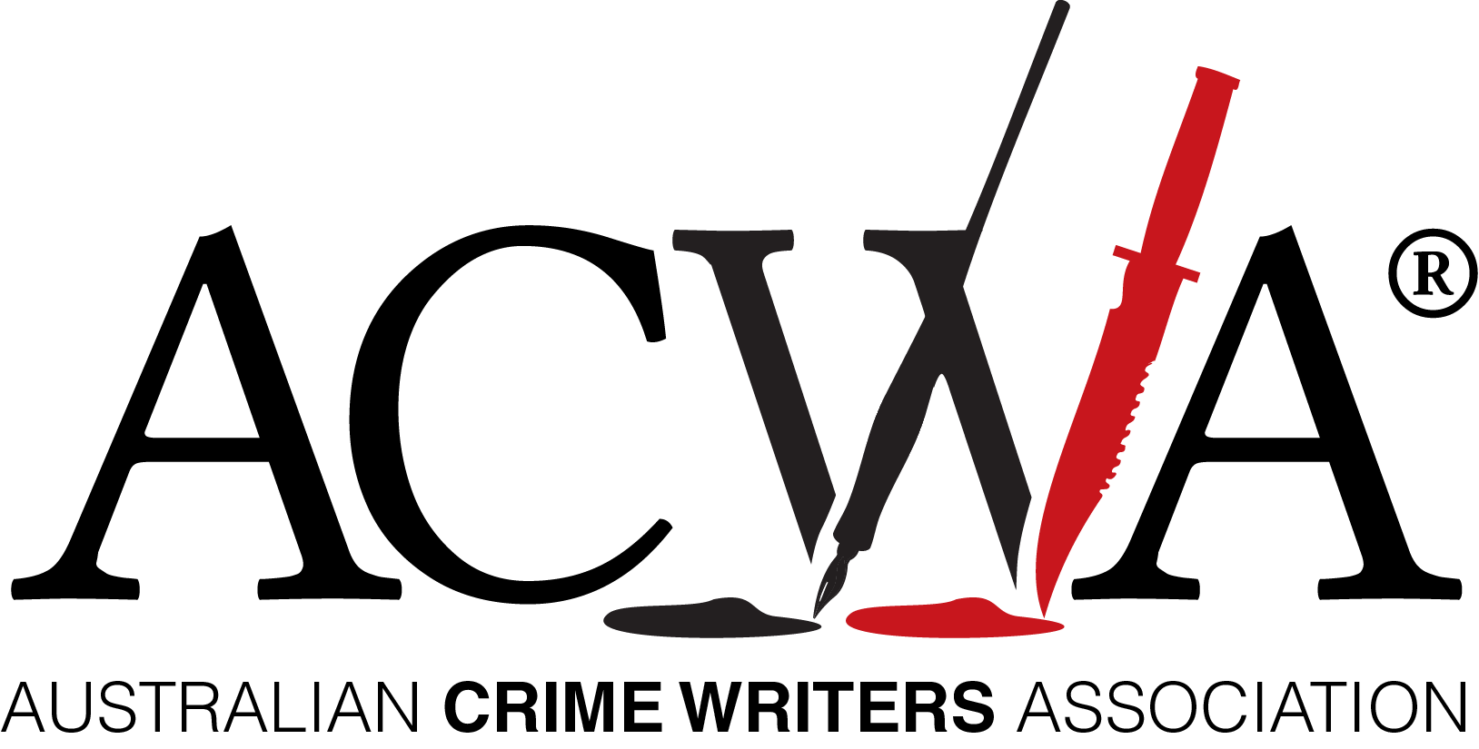
EMBARGOED: 8pm Tuesday 24 August, 2021

Announcing the 2021 Ned Kelly Awards Winners

Tuesday 24 August 2021

The Australian Crime Writers Association received a huge increase in entries for this year’s Ned Kelly Awards. The Awards are an annual celebration of the best in Australian crime writing. In 2021 there were 149 entries, almost double the entries of the previous year. The entries were narrowed down to 22 books shortlisted across the four award categories; Best Crime Fiction, Best True Crime, Best Debut Crime Fiction, and Best International Crime Fiction published in Australia.

2021 BEST CRIME FICTION
The winner of the 2021 Ned Kelly Award for Best Crime Fiction is Consolation, by Garry Disher (Text).
Disher was awarded the Ned Kelly Lifetime Achievement Award in 2019 and has previously won Ned Kelly Awards for Chain of Evidence (2007) and Wyatt (2010).
The judges praised Disher’s masterly writing of place and landscape. In particular, his unsentimental portrayal of the precarious aspect of rural life and its impact on ordinary people.

2021 BEST TRUE CRIME
The winner of the 2021 Ned Kelly Award for Best True Crime is Stalking Claremont by Bret Christian (Harper Collins).
Stalking Claremont is the story of Australia's longest-running homicide investigation by veteran newsman Bret Christian.
The judges said Stalking Claremont is a riveting story of the search for a serial killer which involved an investigation plagued by tunnel vision; devastated, brave families; lives wrecked by false accusations; and the forensic brilliance that finally saw a result.
2021 BEST DEBUT CRIME FICTION
The winner of the 2021 Ned Kelly Award for Best Debut Crime Fiction is The Second Son by Loraine Peck (Text).
The Second Son is a story of organised crime and family honour set in the western suburbs of Sydney.
The judges praised the strong character-driven plot and the realistic setting in multicultural Sydney. The intercutting of family dynamics and organised crime action brings a heightened level of both engagement and tension to The Second Son.
2021 BEST INTERNATIONAL CRIME FICTION
The winner of the 2021 Ned Kelly Award for Best International Crime Fiction published in Australia, is We Begin at the End by Chris Whitaker (Allen & Unwin).
The judges said: We Begin at the End is a complex and dark thriller which explores family, friendship and redemption. The story is driven by the character of the outlaw Duchess Ray Radley, a wise child carrying the load of generational trauma.
Australian Crime Writers Association chair Robert Goodman said once again the Ned Kelly Awards have captured the breadth and vibrancy of Australia’s crime writing scene.
‘In these difficult pandemic times, people need an escape more than ever. The sheer number of entries this year shows that crime authors are prepared to stand and deliver.’

‘The Ned Kelly Awards have always been recognised for showcasing both emerging and established Australian crime writing talent. It is wonderful to see not only that our well known authors are still delivering astounding crime writing but also the amazing depth of new talent across all award categories.’

ABOUT THE NED KELLY AWARDS

The Ned Kelly Awards are Australia’s oldest and most prestigious prizes for crime fiction and true crime writing. Established in 1996, and now in their twenty-sixth year, previous winners include: Peter Temple, Shane Maloney, Gabrielle Lord, Candice Fox, Garry Disher, Helen Garner, John Silvester, Jane Harper, and Duncan McNab.

Contact:

Australian Crime Writers Association chair Robert Goodman
Further details available at: www.autcrimewriters.com

