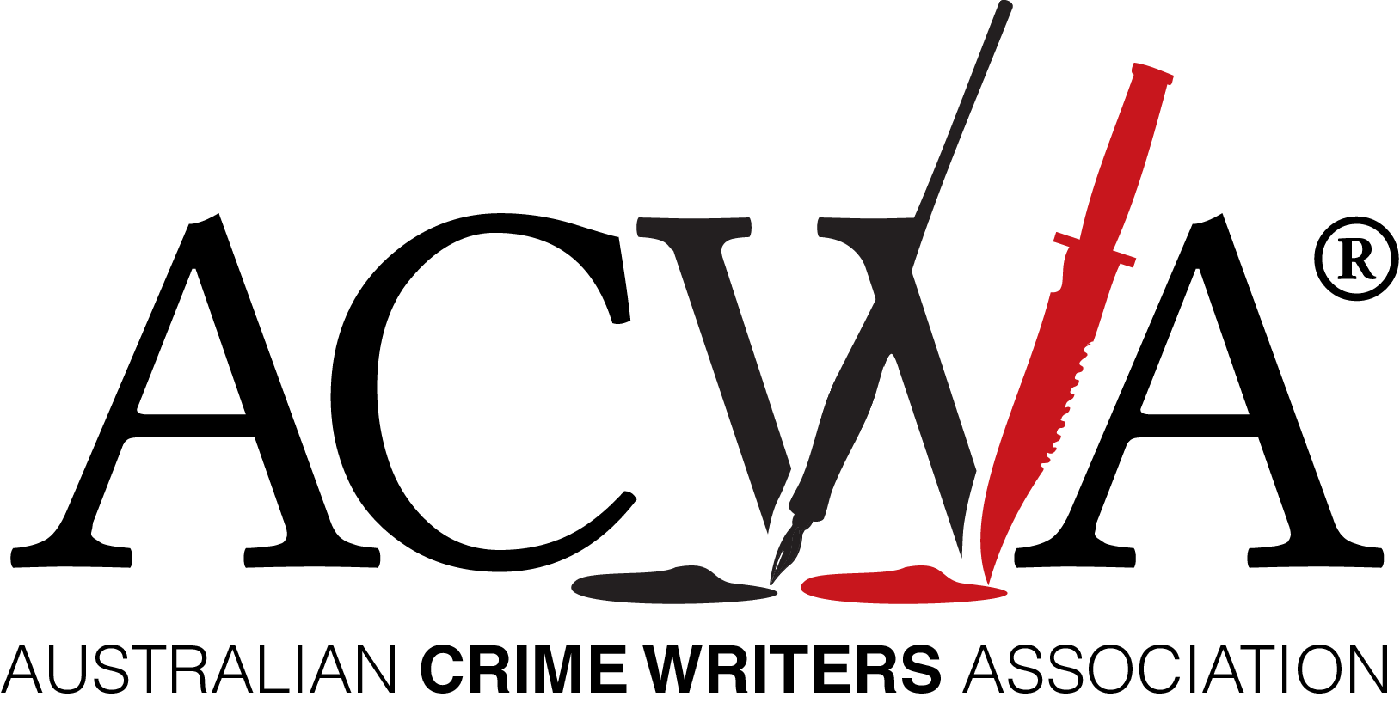
EMBARGOED UNTIL: WEDNESDAY 14 OCTOBER, 2020, 8PM

The 2020 Ned Kelly Awards Winners

Wednesday 14 October, 2020

New authors featured strongly in this year’s Ned Kelly Awards for Australian crime writing. Started in 1996 and run by the australian Crime Writers’ Association, the Awards are an annual celebration of the best in Australian crime writing. This year out of almost 80 entries, 20 books were shortlisted across four categories.

The winner of the 2020 Ned Kelly Award for Best Crime Fiction was The Wife and the Widow, the second novel by screen-writer Christian White (Affirm Press). White was shortlisted in the Ned Kelly Awards last year for his debut, The Nowhere Child. He backed that book up with The Wife and the Widow, which judges described as ‘a cleverly plotted thriller with a twist that will knock you sideways’. The Wife and the Widow is an atmospheric mystery told from two different perspectives.
Winner of the Ned Kelly Award for Best True Crime, Bowraville (Penguin Random House), is also journalist Dan Box’s second book. Bowraville, about the murder of three Aboriginal people in the same town, was recognised by the judges as ‘an important story that addresses themes of endemic racism and justice as well as the ethics of true crime reporting’.
The winner of the 2020 Ned Kelly Award for Best Debut Crime Fiction was Natalie Conyer for Present Tense (Clan Destine Press). Present Tense, set in Cape Town, explores the politics of present day South Africa through the eyes of a veteran police officer with a complicated past. Judges commented on the book’s well realised setting, flawed characters, and complex, taut plot’.
For the first time, the Ned Kelly Awards also included a category for Best International Crime Fiction published in Australia. World-renown Irish author Adrian McKinty, now based in America, won this new award for his latest book The Chain (Hachette Australia). Judges praised McKinty’s novel as ‘a wild rollercoaster ride of read… a gripping and original thriller.’
Australian Crime Writers Association chair Robert Goodman said this year’s crop of winners demonstrate the vibrancy of the Australian crime writing scene.
‘The Ned Kelly Awards has always prided itself on recognising great Australian crime writing talent. And while it was great to see some established names in our short lists it is also thrilling to see these Awards being won by some of our newer authors. It is testament to the vitality of Australian crime writing.’

‘As well as recognising our local talent we also wanted to celebrate Australian readers’ love of international crime fiction. So we were excited to present our first Award for International Crime Fiction’ Goodman said.

AWARDS
Best Crime Fiction

The Wife and the Widow, by Christian White
Best Debut Crime Fiction
Present Tense, by Natalie Conyer
Best True Crime
Bowraville, by Dan Box
Best International Crime Fiction
The Chain by Adrian McKinty.

ABOUT THE NED KELLY AWARDS

The Ned Kelly Awards are Australia’s oldest and most prestigious prizes for crime fiction and true crime writing. Established in 1996 and now in their twenty-sixth year, previous winners include: Peter Temple, Shane Maloney, Gabriel Lord, Candice Fox, Garry Disher, Helen Garner, John Silvester and Duncan McNab.

Contact:

Australian Crime Writers Association chair Robert Goodman
mobile 0468 822 830
Further details and all video assets available at: www.autcrimewriters.com

