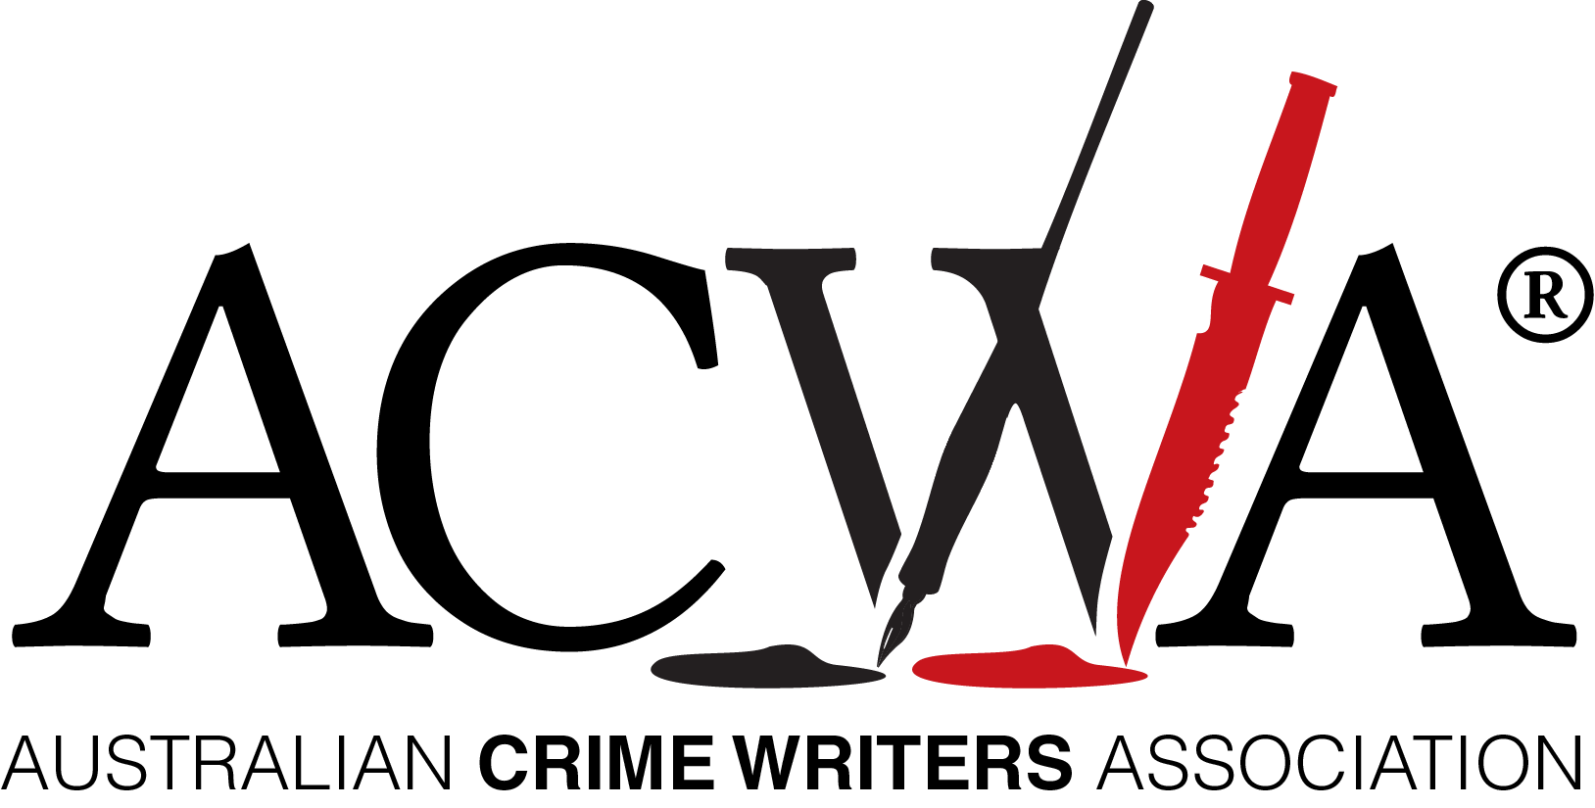
Announcing …
The 2021 Ned Kelly Awards Shortlists

A record number of entries in the Ned Kelly Awards for crime writing

Wednesday 28 July 2021

Many Australian writers appear to have spent their Covid lockdown producing crime fiction and true crime books. This year’s Ned Kelly Awards had 149 entries, a fifty percent increase on previous years.

Australian Crime Writers Association chair Robert Goodman said the large increase in entries this year demonstrates that Australian crime writing and reading has never been stronger.

‘This is not just evident in the number of submissions but in the diversity and quality of the entries. Congratulations to all our entry authors.’

‘There are plenty of familiar names among the best crime fiction and true crime entries but also an exciting crop of new voices across all categories, particularly those in contention for the Best Debut Crime Fiction Award.’ Goodman said.

This is the second year of the Ned Kelly Awards for Best International Crime Fiction published in Australia.

‘It is exciting to recognize not only our incredible home grown talent but also some of the world’s top international crime authors,’ Goodman said.

2021 Ned Kelly Award for BEST CRIME FICTION (8)
Consolation by Garry Disher (Text)
Gathering Dark by Candice Fox (Penguin Random House)
A Testament of Character by Sulari Gentill (Pantera Press)
The Survivors by Jane Harper (Pan Macmillan)
The Good Turn by Dervla McTiernan (Harper Collins)
Tell Me Lies by J.P. Pomare (Hachette)
When She Was Good by Michael Robotham (Hachette)
White Throat by Sarah Thornton (Text)

2021 Ned Kelly Award for BEST DEBUT CRIME FICTION (4)
The Debut Crime Fiction shortlist covers a diverse range of new voices including:
The Good Mother by Rae Cairns (Bandrui Publishing)
The Second Son by Loraine Peck (Text)
The Bluffs by Kyle Perry (Penguin Random House)
The Night Whistler by Greg Woodland (Text)

2021 Ned Kelly Award for BEST TRUE CRIME (5)
The Husband Poisoner by Tanya Bretherton (Hachette)
Stalking Claremont: Inside the hunt for a serial killer by Bret Christian (Harper Collins)
Public Enemies by Mark Dapin (Allen and Unwin)
Hazelwood by Tom Doig (Penguin Random House)
Witness by Louise Milligan (Hachette)

2021 Ned Kelly Award for BEST INTERNATIONAL CRIME FICTION (5)

The 2021 Ned Kelly Award for international crime fiction included submissions from some of the world’s biggest-selling crime fiction authors and some exciting new names. The shortlist has been narrowed down to:

The Guest List by Lucy Foley (Harper Collins)
The Secrets of Strangers by Charity Norman (Allen and Unwin)
Take Me Apart by Sara Sligar (Text)
We Begin at the End by Chris Whittaker (Allen and Unwin)
Broken by Don Winslow (Harper Collins)

ABOUT THE NED KELLY AWARDS

The Ned Kelly Awards are Australia’s oldest and most prestigious recognition of crime fiction and true crime writing. First established in 1995 and now in its twenty-sixth year, previous winners include: Peter Temple, Shane Maloney, Gabrielle Lord, Sarah Bailey, Adrian McKinty, Helen Garner and Duncan McNab.

Contact:

Australian Crime Writers Association chair Robert Goodman
Mobile: 0468 822 830
Further details of the Awards, including previous winners and video assets available here: www.austcrimewriters.com

