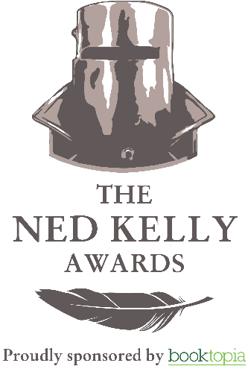
THE NED KELLY AWARDS 2019 SHORTLIST ANNOUNCED

Monday August 19: The Australian Crime Writers Association has announced the shortlist for the NED KELLY AWARDS 2019. Now in its 24th year the Awards are Australia’s oldest and most prestigious crime writing awards.

Past winners have included Jon Cleary, Peter Corris, Adrian McKinty, Jane Harper, Helen Garner, Peter Temple and Michael Robotham. This year has seen the largest number of entries received in the Awards’ history.
ACWA’s Deputy Chair, Robert Goodman said, “The Ned Kelly Awards celebrate some of Australia’s most exciting crime storytellers. They play a vital role in championing local crime writers and the Australian publishing industry both here and overseas.
“The three 2019 shortlists contain a diverse collection of works from both emerging writers and some of our best-known and best-loved crime authors.”
“I congratulate all authors on making this year’s shortlists. They contribute not only to our cultural life but demonstrate Australia’s well-deserved reputation as the home of some of the world’s best crime writing.”
The awards will be held in Sydney on Friday September 6 at the Harold Park Tramsheds and will be MCed by Jane Clifton as part of the BAD Sydney Crime Writers Festival. For tickets and further information, go to https://www.austcrimewriters.com .

The Ned Kelly Awards are proudly supported by Booktopia.
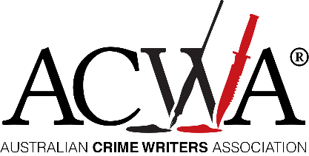
FOR FURTHER INFORMATION, PLEASE CALL DEBBIE MCINNES, DMCPRMEDIA
T: 02 9550 9207 E: debbie@dmcpr.com.au

2019 Ned Kelly Shortlisted authors

Best Crime

Killshot – Garry Disher (Text Publishing)
Gone By Midnight – Candice Fox (Penguin Random House)
The Spotted Dog – Kerry Greenwood (Allen & Unwin)
The Lost Man – Jane Harper (Macmillan Australia)
The Other Wife – Michael Robotham (Hachette Australia)
Live and Let Fry – Sue Williams (Text Publishing)

Best First Fiction

The Portrait of Molly Dean – Katherine Kovacic (Echo Publishing)
The Rúin – Dervla McTiernan (HarperCollins Australia)
The Yellow House – Emily O’Grady (Allen & Unwin)
Greenlight - Ben Stevenson (Penguin Books Australia)

Best True Crime

Eggshell Skull - Bri Lee (Allen & Unwin)
The Arsonist - Chloe Hooper (Penguin Random House)
The Lindt Café Siege - Deborah Snow (Allen & Unwin)
Waiting for Elijah - Kate Wild (Scribe Publishing)

FOR FURTHER INFORMATION, PLEASE CALL DEBBIE MCINNES, DMCPRMEDIA T: 02 9550 9207 E: debbie@dmcpr.com.au

